Brainstorm & Idea Prioritization

Date: 31 January 2025

Team ID: LTVIP2025TMID28567

Project Name: Importing and Securing Data in ServiceNow

Maximum Marks: 4 Marks

# Step 1: Team Gathering, Collaboration and Select the Problem Statement

Problem Statement:  
How can we effectively import data into ServiceNow from various external sources while ensuring data security, integrity, and compliance throughout the process?

Focus Areas for Discussion:  
- Data import methods (e.g., CSV, API, IntegrationHub, MID Server)  
- Security best practices (e.g., encryption, access controls, data validation)  
- Handling sensitive or regulated data (e.g., PII, HIPAA, GDPR)  
- Automation vs. manual data loading  
- Role-based access and audit trails

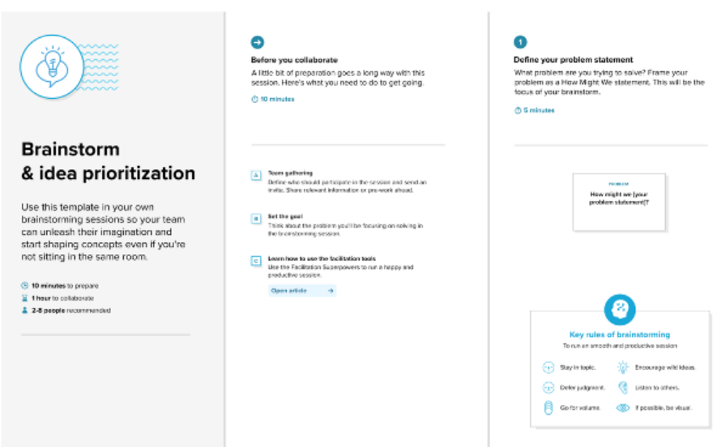

# Step 2: Brainstorm, Idea Listing and Grouping

Ideas (examples):  
1. Use IntegrationHub for secure, automated API-based imports  
2. Implement field-level encryption for sensitive data fields  
3. Create a data validation layer before final import  
4. Use ACLs (Access Control Lists) for restricting imported data visibility  
5. Schedule regular audits on imported data logs  
6. Leverage MID Server for secure data movement from on-premise sources  
7. Mask PII during import with transform scripts  
8. Train team on ServiceNow import sets and security modules

Group Ideas into Themes:  
- Automation & Tools  
- Security & Compliance  
- Data Integrity & Validation  
- Governance & Monitoring

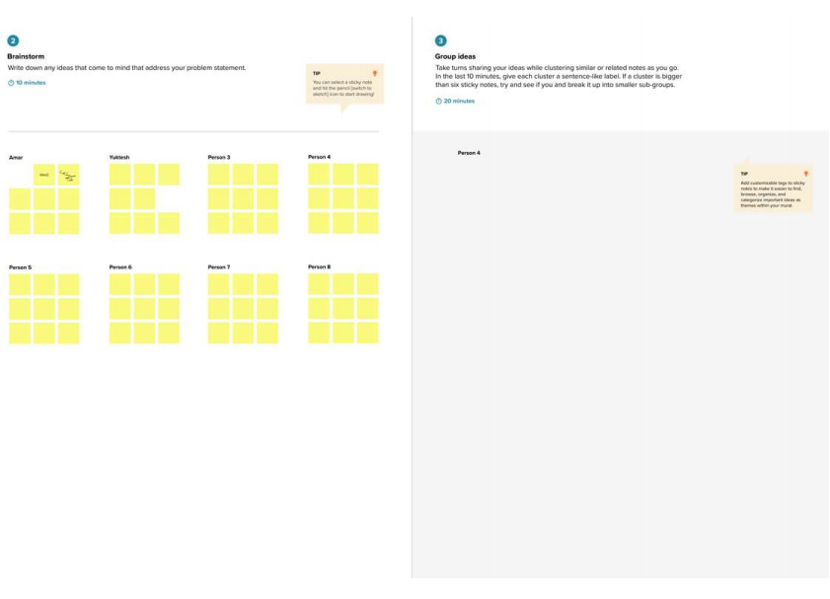

# Step 3: Idea Prioritization

|  |  |  |  |
| --- | --- | --- | --- |
| Idea | Impact | Feasibility | Priority (H/M/L) |
| Use IntegrationHub for automated imports | High | High | High |
| Field-level encryption | High | Medium | High |
| Data validation layer | Medium | High | Medium |
| MID Server integration | High | Medium | Medium |
| Audit log automation | Medium | Medium | Medium |
| Training program | Medium | High | High |
| Masking PII with scripts | High | Medium | High |

Team Members: Sarat Chandra Cheekatla, Devaki V, Vallu Mahendra

